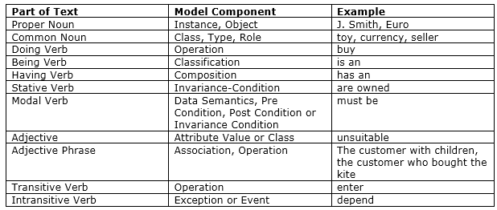

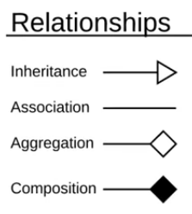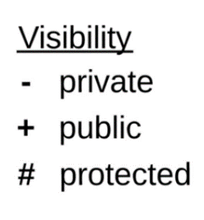

Completely copy of the class (can access private and protected members

Aggregation specifies a whole and its parts (copy of that class but can’t access private members). It can exist outside that class.

1 **Display currently available stock**

**2** Database to store information

3 V**irtual basket**

**4 Allow products to be returned**

**5 Allow catalogue of products to be changed**

**6 Create invoices**

**7 users to login**

Composition: Can’t exists without the parent object/class. Will also be destroyed if parent class is destroyed

